William Bartram Image Gallery
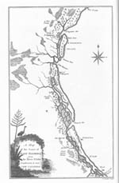
A Map of East Florida, prepared by William Bartram for his book of Travels published in 1791, one of the first science books printed in this country. The map shows the St. Johns River area of his explorations in 1774.
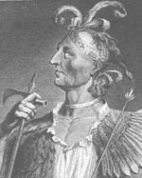
Mico Chlucco, the Long Warrior, a portrait of the Seminole war chief drawn by William Bartram and engraved for the second edition of the book of Travels, published in London, England, in 1792. Bartram urged the federal government to begin discussions with the Seminoles to avert bloodshed.
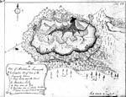
The Alachua Savanna, a large wet prairie of approximately 18,000 acres, is as. Bartram has sketched, a mosaic of meadow marsh, ponds, hardwood hammocks (forests), and pine flatwoods-habitats for a large number of animals and plants, including the sandhill crane. The source of this manuscript image, American Philosophical Society was founded in Philadelphia by Benjamin Franklin and John Bartram, William Bartram's father.
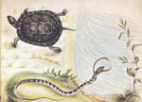
Spotted Turtle (Clemmys guttata), and Corn Snake (Elaphe guttata), drawn in watercolor by William Bartram on one sheet to save paper, shows the naturalist's strengths and weaknesses as an artist. The "Wampon Snake" is swallowing a smaller snake.
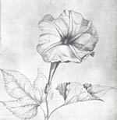
Morning Glory (Merriama dissecta) in detail exemplifies William Bartram's fine flower drawing.
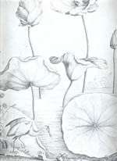
The American Lotus (Nelumbo lutea), a beautiful large aquatic plant admired by William Bartram is shown here with a heron drawn to a different scale.
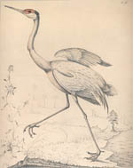
Sandhill Crane (Grus canadensis pratensis). the Florida subspecies here performing its mating dance, William Bartram called by the Creek name "Wattoola." Because sandhill cranes lay only two eggs in grassy mounds in undisturbed marshes, Paynes Prairie Preserve is an important nesting site in Florida.
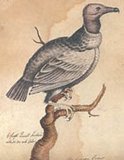
The Black Vulture (Coragyps atratus) is a species that William Bartram introduced to science. He described this important scavenger as a gentle bird.
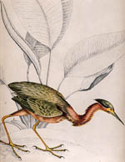
The Green Heron (Butorides virescens), drawn by William Bartram with the aquatic plant, thalia, demonstrates his skills as a bird artist.
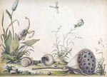
This little landscape drawn in watercolor shows the biodiversity that Bartram admired in Florida: a seed pod of the American lotus, an immature water snake, a large land snail (white-lipped globe) hummingbird, dragonfly, pickerel weed (with flower spike), arrowleaf and water lettuce.
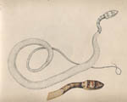
Coachwhip (Coluber flagellum) was Bartram's favorite species snake, "as innocent as a worm" and almost tame.
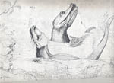
American alligators (Alligator mississipiensis), two bull 'gators in this pen-and-ink drawing by William Bartram snort like Chinese dragons. No section of Bartram's book of Travels was better read or more often quoted than his descriptions of alligators.

